

Mohammad Ali Jinnah University

Chartered by Government of Sindh - Recognized by HEC

**Assignment 02- Case Studies**

**Name:** Muhamad Fahad

**Id:** FA19-BSSE-0014

**Subject:** SCD (Software Construction and Development)

**Section:** AM

**Teacher:** Muhammad Tauseef

**Date:** Wednesday, March 24, 2021

**Q: Consider the following Scenarios and suggest the software process model with the justifications. Remember if you have more than one model suggestions then please write other suggestions too.**

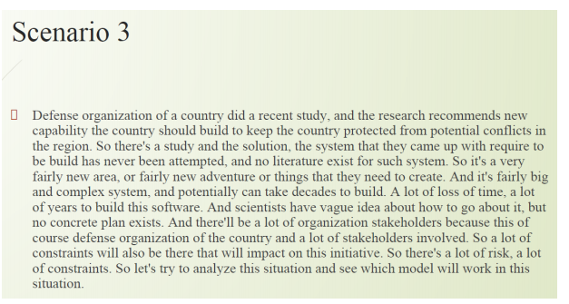

Answer: Spiral modal

Reasons:

* The solution, the system has never been attempted to build, and no literature exist for

Such system.

* It’s fairly big and complex system, and potentially can take decades to build.
* A lot of loss of time, a lot of years to build this software.
* An idea about how to go about it, but no concrete plan exists.
* And there’ll be a lot of organization stakeholders
* So there’s a lot of risk, a lot of constraints

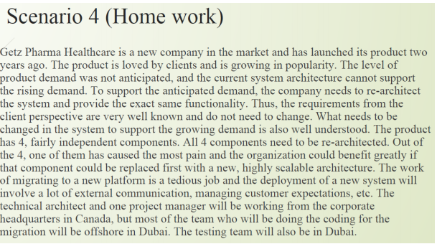

Answer: Increment Model

Reasons:

* The company needs to re-architect the system and provide the exact same functionality.
* The client perspective are very well known and do not need to change.
* All 4 components need to be re-architected.
* Out of the 4, one of them has caused the most pain and the organization could benefit greatly if that component could be replaced first with a new, highly scalable architecture.